Frank’s Jeweller’s Branding, Writing, and Style Guide
Overarching Goal: Bring new customers into the store

4 Main Content Strategies to Build Frank’s Online Brand and drive traffic to store (Insta and Facebook):
- Product Spotlighting: Use pictures of featured products to bring people in to see new products
  - Rebecca and Sydney
- Spotlight Staff Knowledge: Interview, video, or picture different aspects of what to look for in the quality of a diamond, ring, sizing, etc.
  - Rebecca
- Spotlight Historical Artefacts: Show off the history of Frank’s Jewellers through the years with different artefacts and pictures that differentiate the business from competing big box chains. Show the family of the family business.
  - Eleni
- Spotlight Love Stories: Film, interview, and picture stories of different couples who have purchased with Franks over the years. See what you can gather: Perhaps you can show the couple with wedding pictures from a while back vs. today, film them telling their story etc.
  - Jill
- News? Trends? One-offs? Miscellaneous?

All of these strategies aim to build a community selling the meaning and sentiment of the diamond as opposed to selling the diamond itself. By distinguishing Frank’s brand, we can then engage and work on customers to become loyal brand advocates, so they can eventually contribute their own testimonials to get word of mouth for the business spreading online.

Technical Specifications  Title font:  Slogan font: (is it the same? As title font?)  colour code: dc8b4b  colour code 666666  colour code 3abb9b  colour code: b3e4d3 | Resources & Tech  All marketing support materials will be created using Canva.com  Login: scopedts@gmail.com  Password: CrystalClear  Photos will also be taken in store.
Overall brand Feel: Emotional, Educational, Frank
Theme of Instagram: Warm colours: wood, traditional, yet classic, gemstones colours (ruby, emerald, sapphire, etc.)

Writing Guidelines
Brand Voice: Genuine, matter of fact, with a touch of humor. Non-binary.
Customer Persona: Techno Taylor
Potential Hashtags: #befrank, #franksat100, #franksjewellers, #100yearsoffranks #uptownwaterloo #shoplocal

Imagery
Logo Size & Placement: ask Bob and Devon. Current logo is below (from website)
Question: Need logo for Instagram profile. Recreate this one above? Will need to adjust for circular shape of instagram profile picture format
Recreated logo for Instagram profile pic:

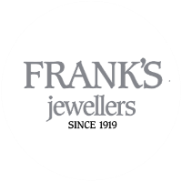

Product Photography Guide

Scope recommends avoiding stock image photos and use backgrounds and images that reflect the history and homey brand of Franks that customers would be familiar with. We want to bring the store’s atmosphere and translated it onto our social presence in order to build the brand and eventually, a community of brand advocates. We will add more details on how to take the pictures as we continue to gather more experience.

For each photo, we want to include a watermark of the Franks logo in the top or bottom right corner of the picture.

Rustic Look:
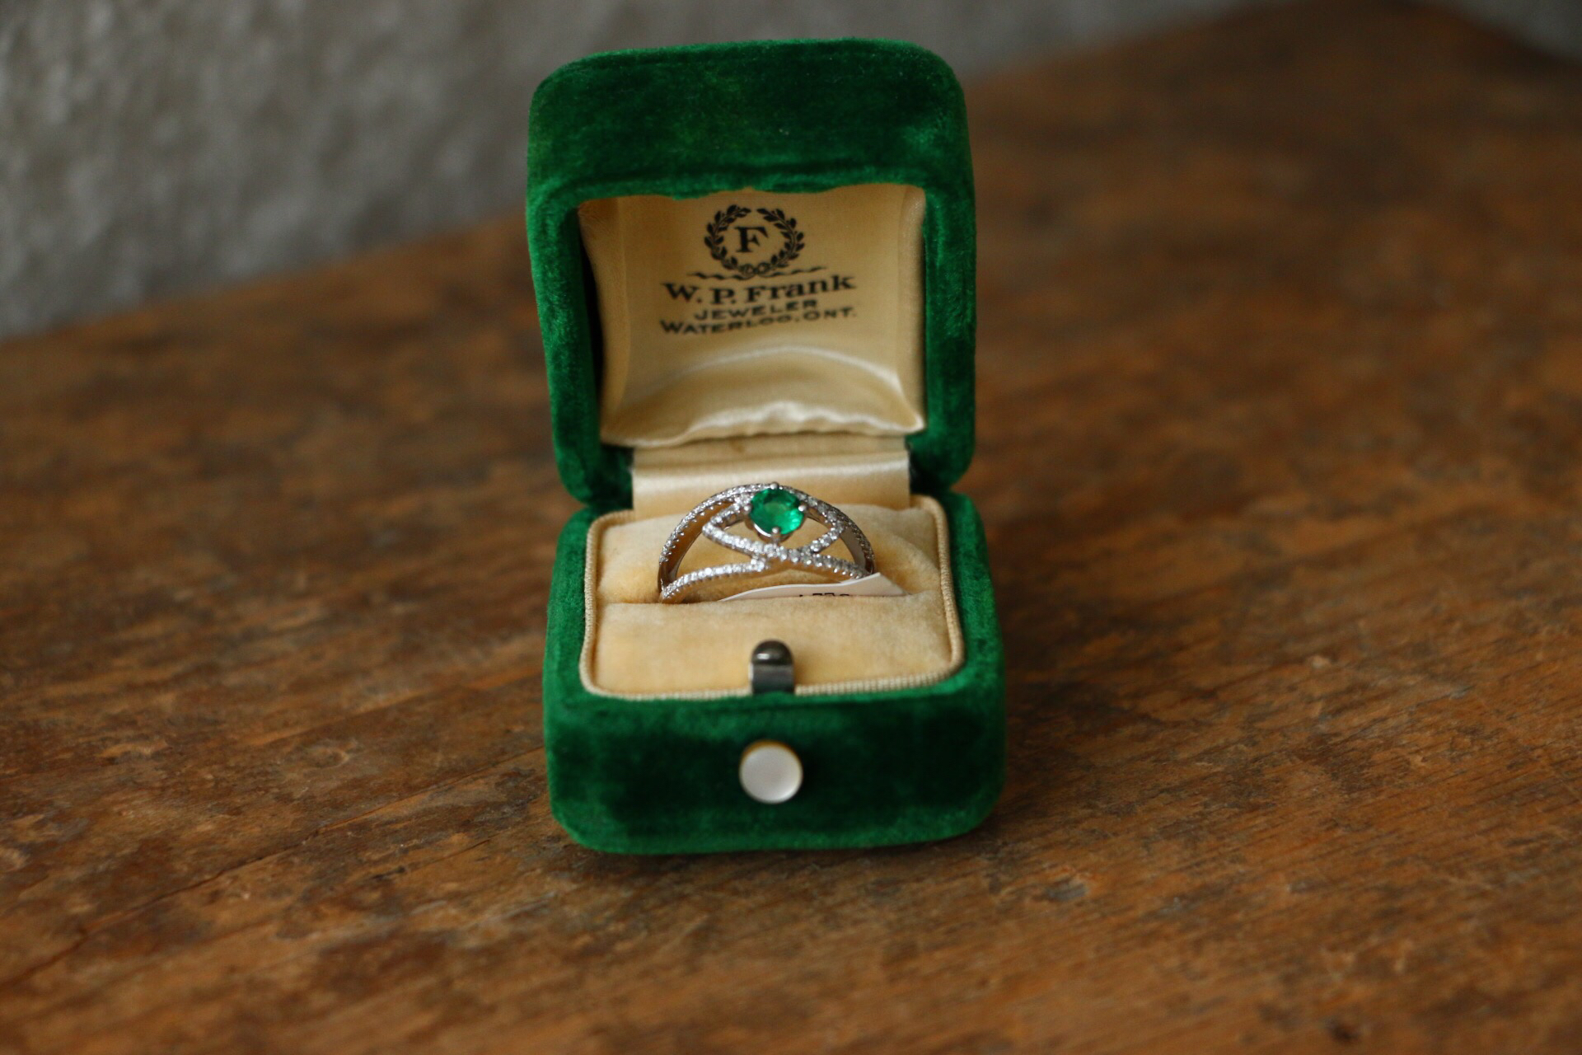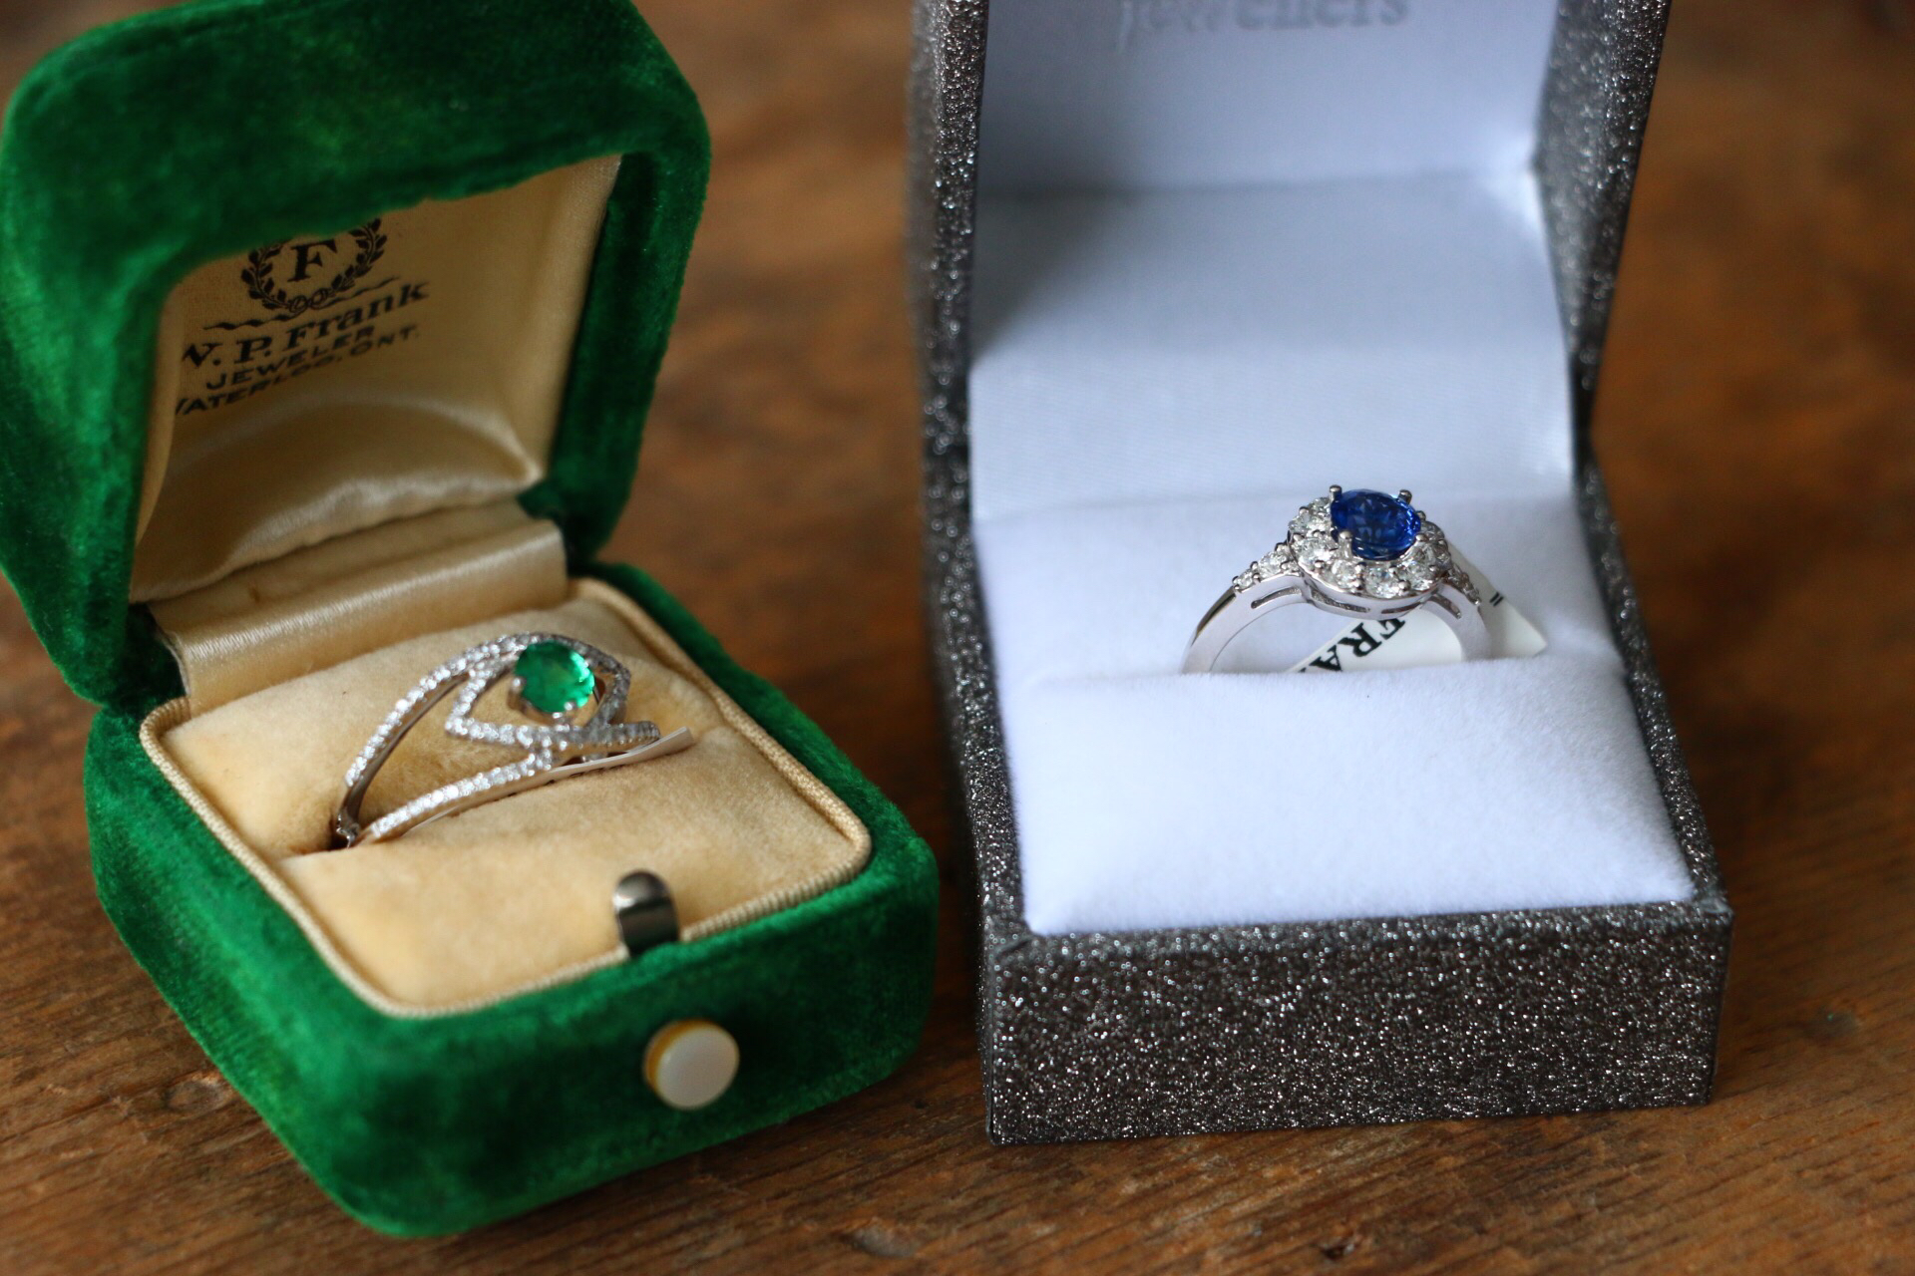

White background:
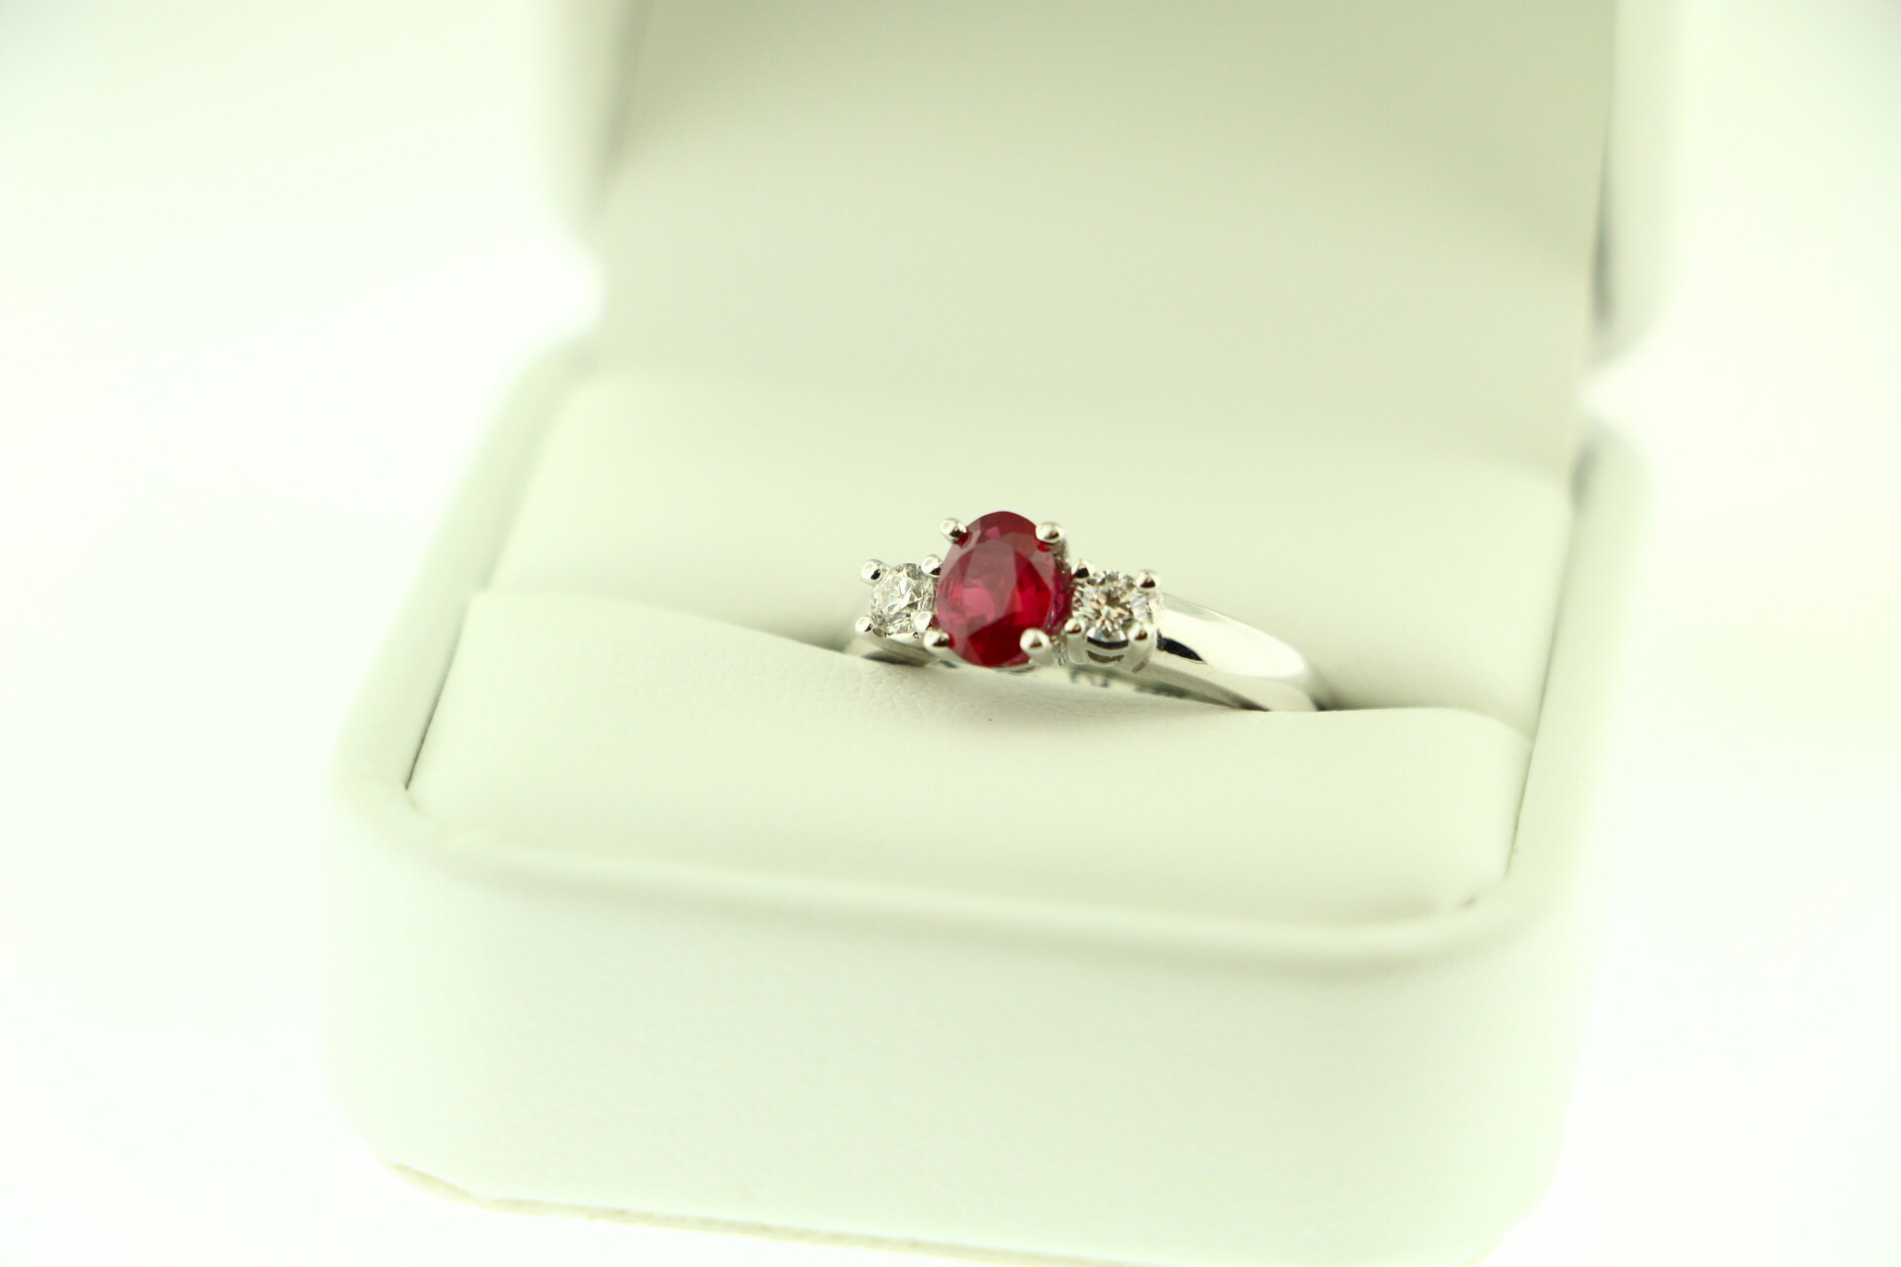

Colour and Themes: (beige and ivory tones can match up with wood as well)
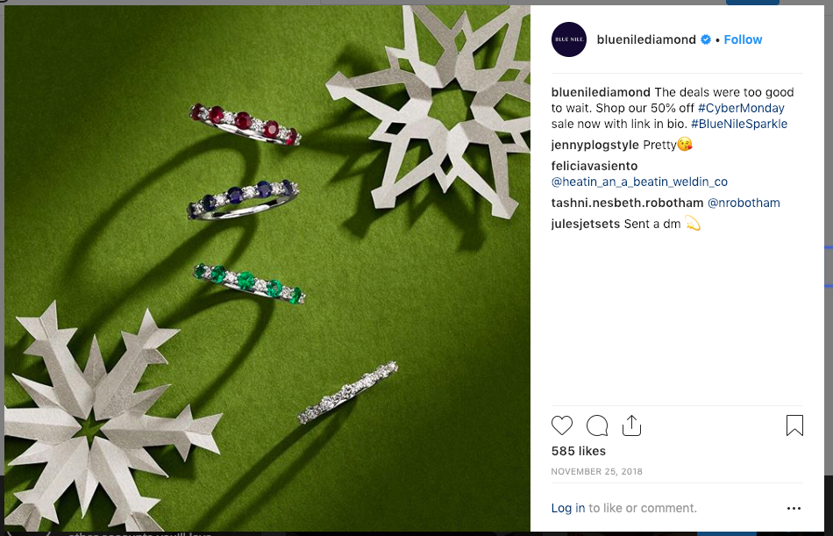

Fabrics that Jill has picked up to bring colour and texture to pictures (Colour intended to also go with wood):
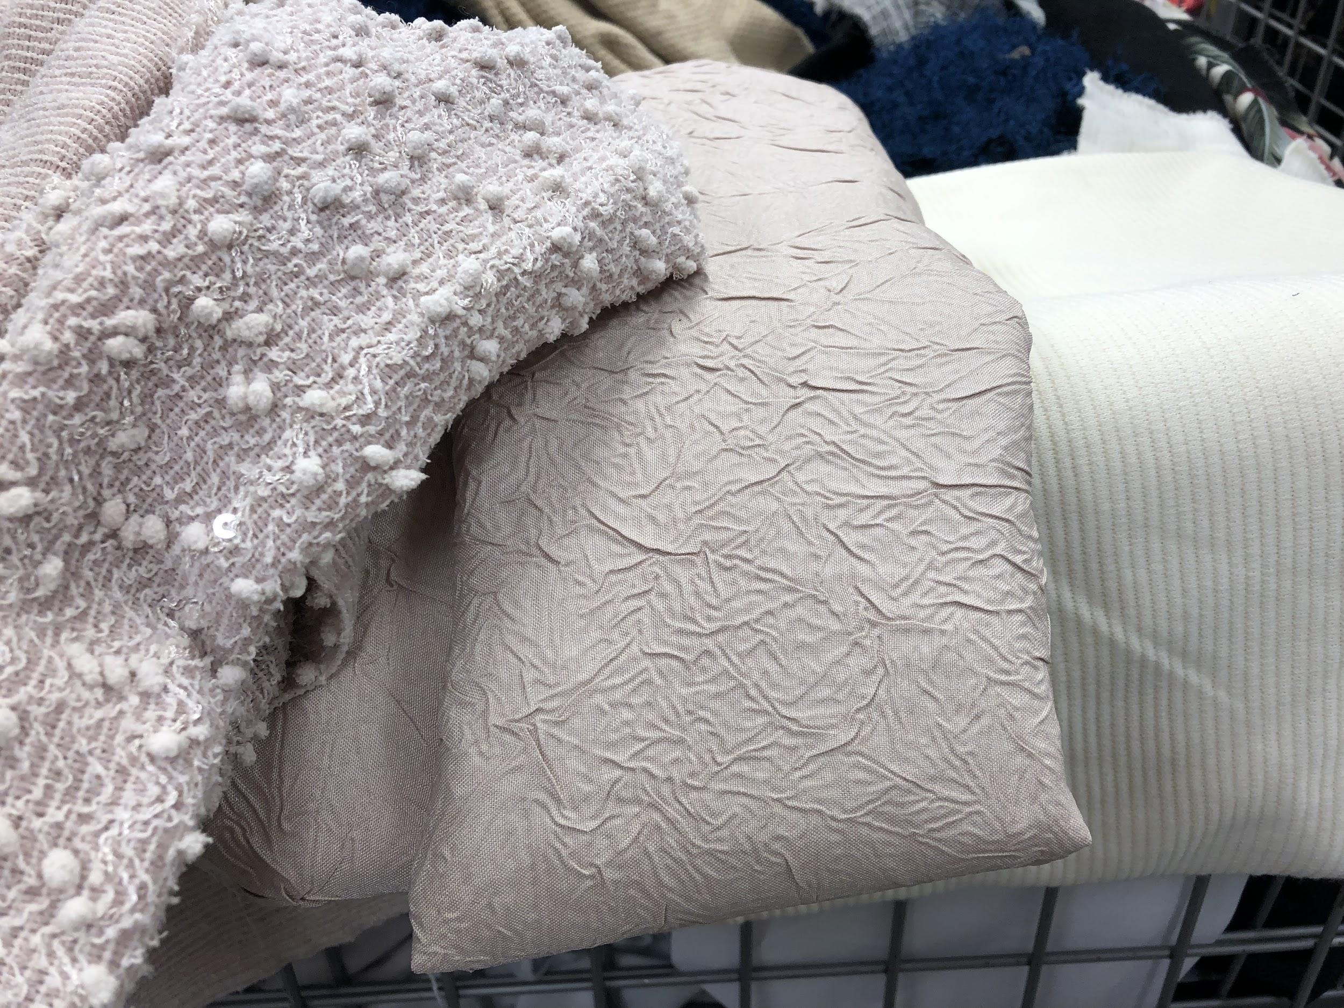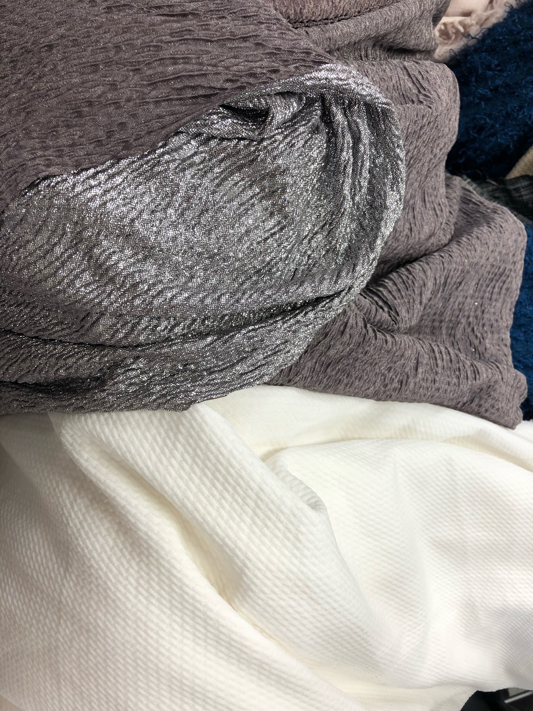

Wearing:
This type of photo would be preferred to showcase the “love stories” (testimonials)

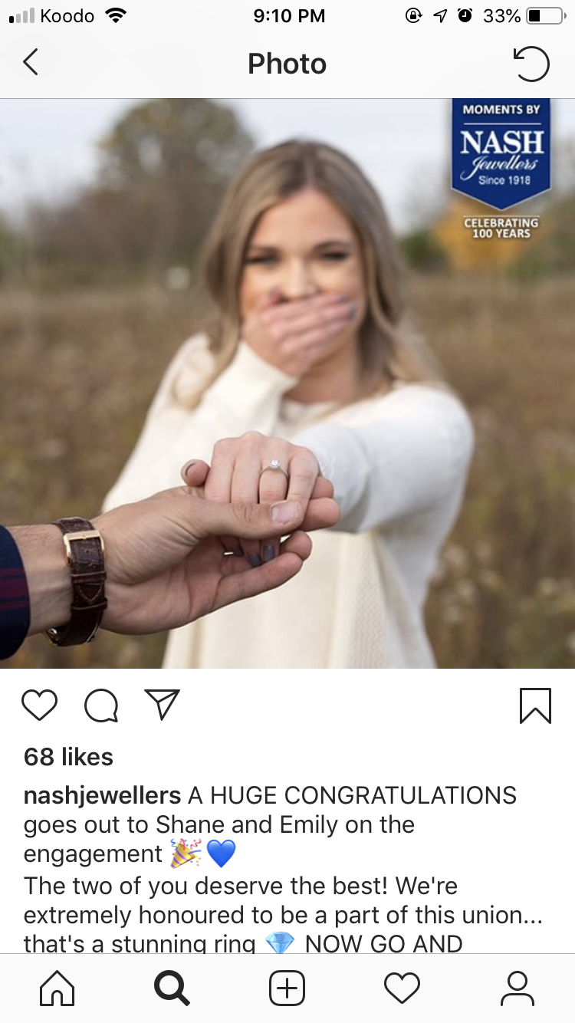

Sample Social Posts

Instagram

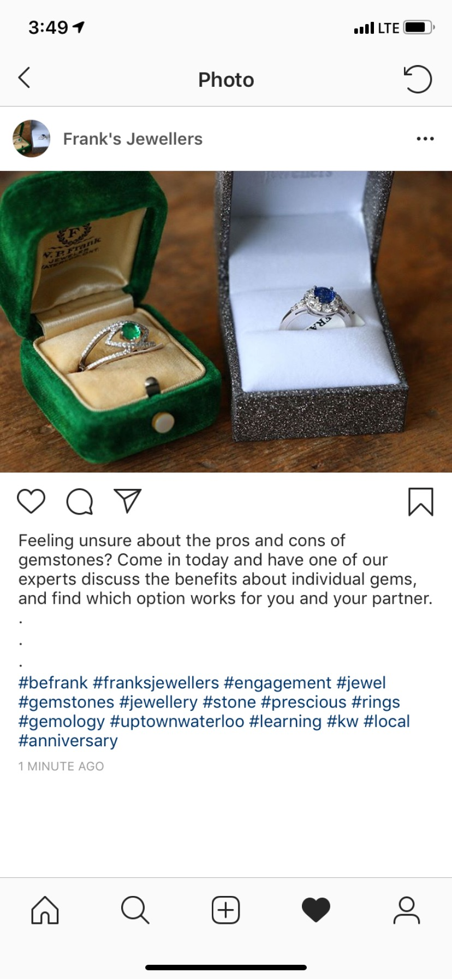

Facebook Post:
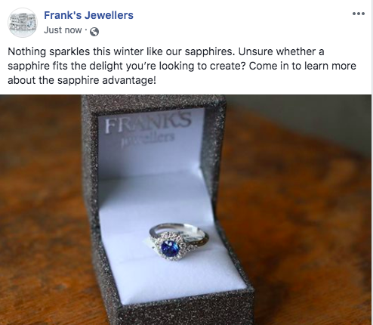

History Post (Instagram): Carousel with close up image of W.P. Frank as the 2nd photo (Swipe right). Where W.P. Frank stands will be tagged to further help audiences put a face to a name.

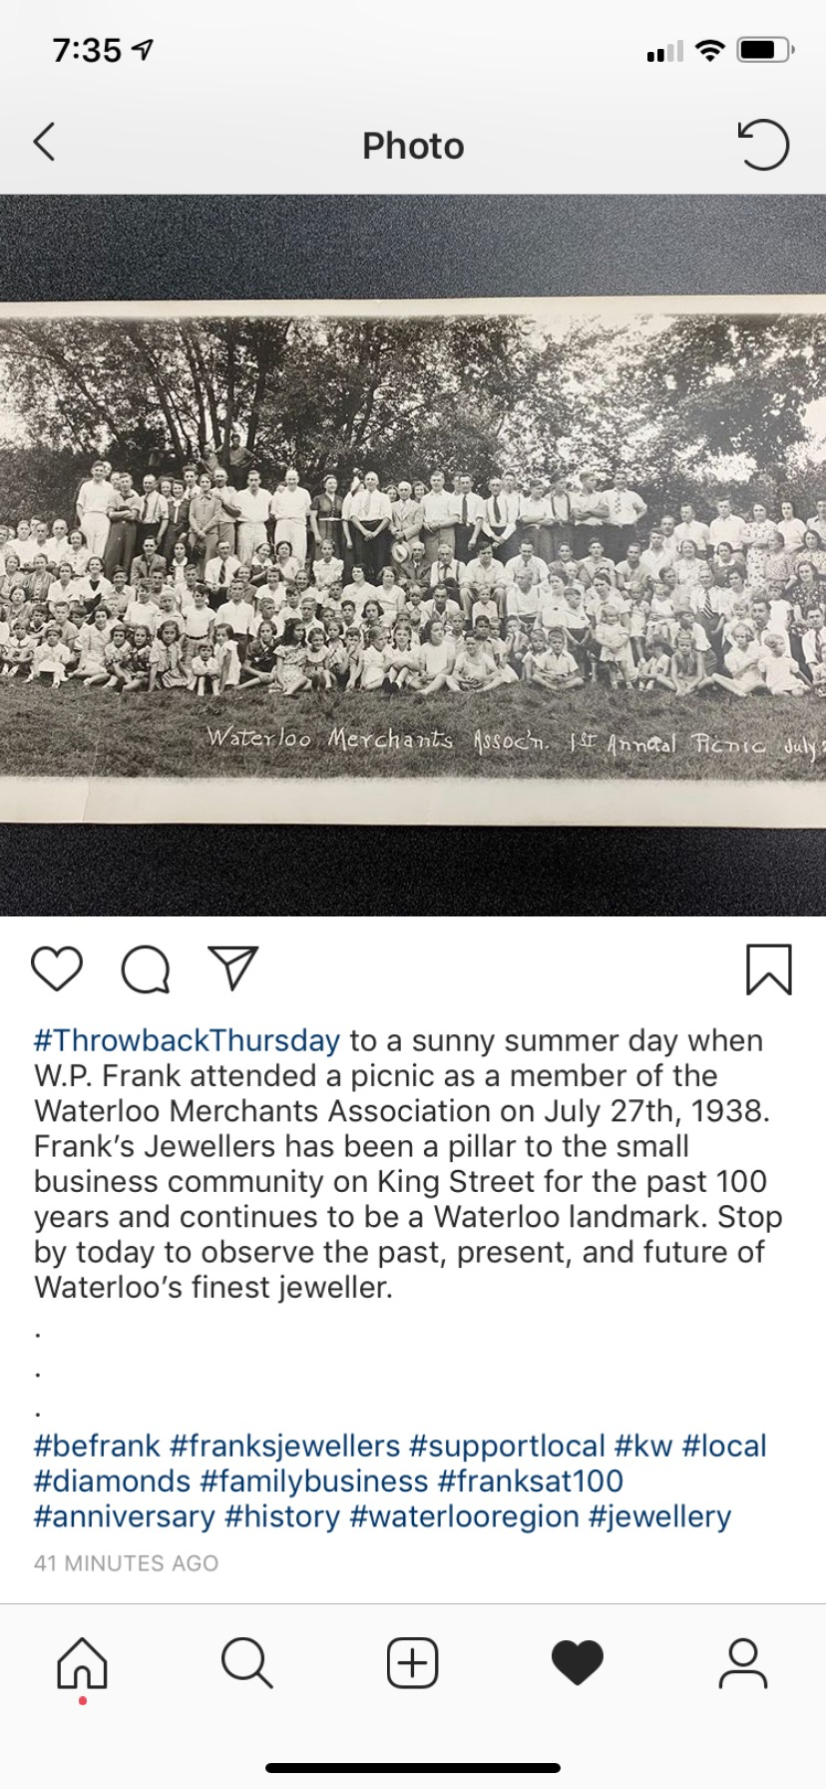

Carousel #2: Still require picture of W.P. Frank 1919 pic in store (First Picture in carousel)

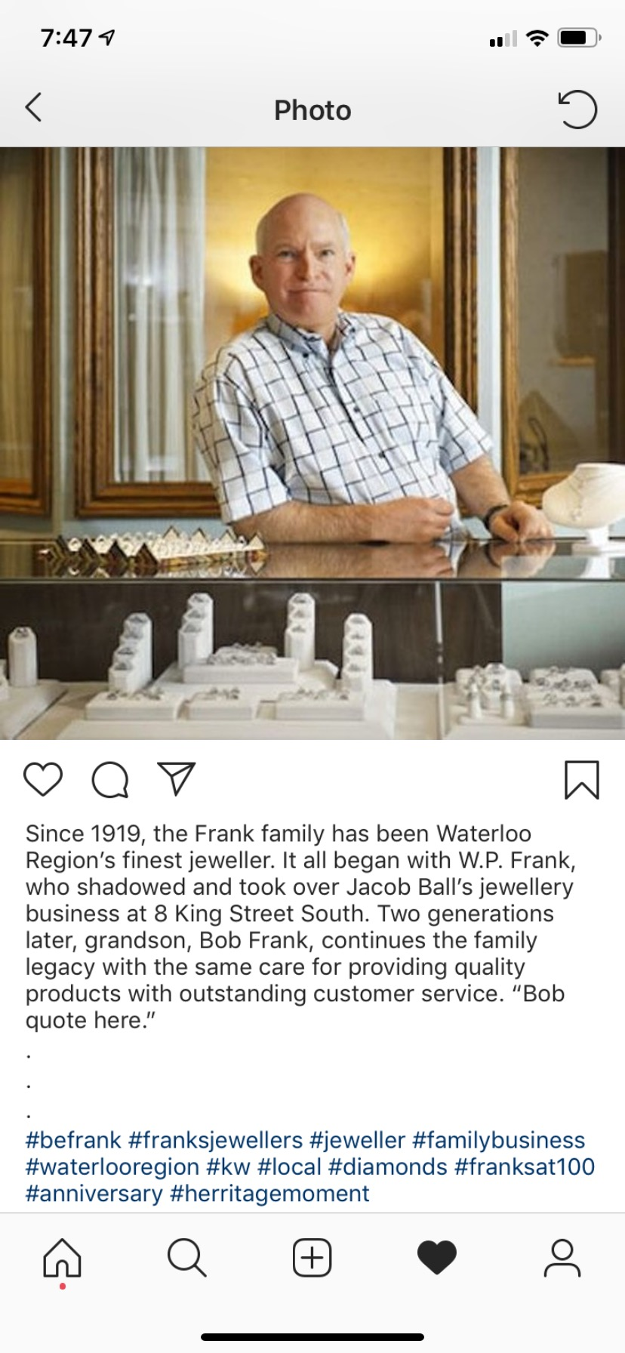

Video Treatments
Media Needed:
- Frank’s Jewelers radio jingle audio file

Video #1: Two Sides to Every Love Story

Suggested release date: 1 week or 2 before Valentine’s Day

Suggested Length: 60 to 90 seconds

Shooting Time Estimate: 3 hours - 30 mins per couple, 30 mins for Bob, plus 1 hour buffer

Logline: Jewelers like Bob Frank play an integral role in any couple’s love story. We hear from couples and how working with a trustworthy and knowledgeable jeweler influenced their love stories.

Characters:
- Three couples:
  - 1 Younger - engaged in the last 2 - 4 years
  - 1 Middle Aged - engaged 15-25+ years ago
  - 1 Older - engaged 35 - 55+ years ago
- Bob

Synopsis:
We meet three couples at different stages in their love stories, all of whom have worked with Frank’s Jewelers. We discuss with them how their love story developed and how working with Frank’s positively influenced an exciting point in their lives.

The point of the video is to show how reliable Frank’s is when it comes to a big, lifelong decision.

Video #2: Product Video

Suggested Release Date: TBD

Suggested Length: 15 to 30 seconds

Shooting Time Estimate: 30 mins to 1 hour.

Purpose: Show off Bob’s extensive product knowledge, get across his straightforward personality, and reinforce him as an authority.

Characters: Just Bob

Synopsis:
Bob illustrates the finer points of a custom piece or other remarkable piece with brief explanations as to why they are the wise choice for a lifelong investment in an engagement ring.

Suggested ShotList:
- Close up shots of the engagement ring with Bob indicating specific features
- Close up shots of the engagement ring by itself
- Medium shots of Bob explaining intricacies of the design and his advice when designing something similar.

Video #3,4,5,6,7: Team Profiles

Suggested Release Date: TBD

Suggested Length: 30 seconds each

Shooting Time Estimate: 30 mins to 1 hour each.

Purpose: Show off the team’s extensive knowledge, introduce them, and their speciality. Show off their personalities and why they think Frank’s is the smart place to buy an engagement ring. How they help their customers make this important decision.

Characters:
- Bob, Billie-Jo, Devon, Teddi , Kelly

Synopsis:
Each team member introduces themselves, their role, and how long they’ve been at Frank’s. They share a favourite anecdote and their favourite part of their work.

